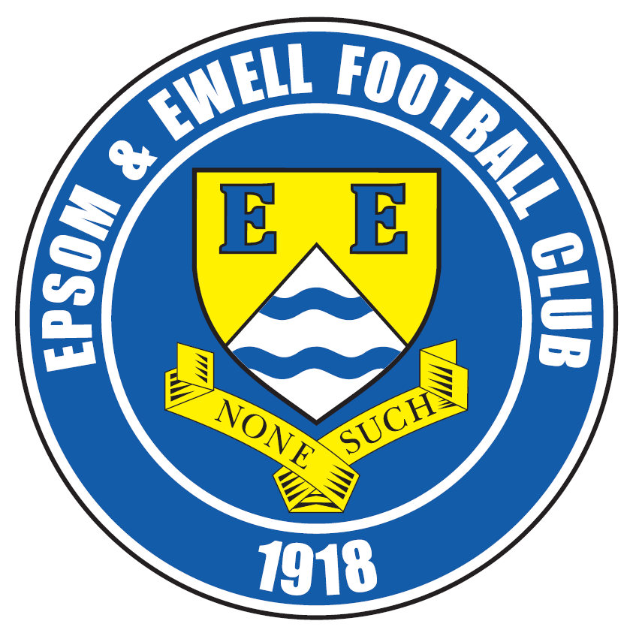 | Epsom & Ewell F.C.  7  v  AFC Hayes  Saturday, 19th September 2015
Today the Salts take on A.F.C. Hayes in a League match. We welcome their players and officials, today’s match officials and our regular supporters.

Our opponents may be better known to some older Epsom supporters as Brook House, as we met on six occasions over a couple of years in the Isthmian League Division Two before it was dissolved and the clubs went their separate ways. We beat them 3-1 in our very first meeting; an early League match in August 2004 at Kingshill Avenue and drew our last 2-2 at Merland Rise in March 2006 with the evergreen Dale Marvell scoring both goals. However, we lost the four matches in between, so we’ll gloss over those!

Now they are back at Step Five where they have so far found things testing. An interesting yardstick could be Colliers Wood United who we beat 3-1 eleven days ago, yet last Saturday Wood won at Brook House by two goals to nil. However, comparisons like this are no real indicator; we’ll have to work hard for the points today and everyone at the club knows it.

The win against Colliers Wood United was a fine one. It did require two late goals and we were under pressure for the early part of the second half, but once they had equalised Kyle Hough’s early goal we got back on top, finished the stronger and deserved the win over the whole 90 minutes.

Then last Saturday we returned to the site of our best performance last season; the 3-0 win at Spelthorne Sports and this time exceeded that result with a 6-2 win. To be honest I am not sure how they got two as most of the game was mostly played in their half! It was a great day to be present as fine finishes flew in from all over the place. The majority of the away matches aren’t that far away really and are often well worth the journey, (not Horsham!) so why not join the travelling supporters as we head to Cove two weeks today?

Before then we host Farnham Town here next Saturday and they look a strong team this season. This will be another difficult game but we are well up with our fixtures so players are having plenty of opportunities for rest and recuperation with all of these spare midweeks. On that subject, we are hoping to see recent absentees Reisse Griffin, Matt Ferdinando, Jakub Kurdziel and Beckett Oliver back shortly, maybe even today, you never know!

Don’t forget the Super Six Predictor! The jackpot is now up to £177 so why not buy a ticket?

Enjoy the game!

Rich

Check us out on Facebook www.facebook.com/epsomandewellfc or on Twitter @EEFCOfficial

Cover photos by Gemma Jarman

- Rob Hendry volleys in our fourth goal against Spelthorne Sports

- Kyle Hough beats the keeper to the ball before scoring our sixth goal

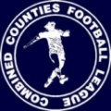
Cherry Red Records
Combined Counties League
Premier Division Table 2015/16
Inc Tuesday 15th September | P | W | D | L | F | A | Pts | GD | H | A
Ashford Town (Mx) | 7 | 7 | 0 | 0 | 17 | 5 | 21 | +12 | 30/4 | 24/10
Epsom & Ewell | 7 | 5 | 2 | 0 | 17 | 7 | 17 | +10 | X | X
Hanworth Villa | 6 | 5 | 1 | 0 | 14 | 1 | 16 | +13 | 21/11 | 23/4
Hartley Wintney | 5 | 5 | 0 | 0 | 27 | 5 | 15 | +22 | 30/1 | 10/10
Camberley Town | 7 | 4 | 2 | 1 | 12 | 8 | 14 | +4 | 16/4 | 20/2
Knaphill | 7 | 4 | 1 | 2 | 16 | 8 | 13 | +8 | 12/3 | 14/11
Colliers Wood United | 7 | 4 | 1 | 2 | 16 | 11 | 13 | +5 | 3-1 | 28/11
Horley Town | 5 | 4 | 0 | 1 | 12 | 4 | 12 | +8 | 27/2 | 28/12
Chessington & Hook | 6 | 3 | 2 | 1 | 9 | 5 | 11 | +4 | 7/11 | 19/3
Windsor | 7 | 2 | 4 | 1 | 11 | 12 | 10 | -1 | 2-2 | 23/1
Guildford City | 7 | 3 | 1 | 3 | 11 | 15 | 10 | -4 | 5/12 | 2/4
Raynes Park Vale | 6 | 3 | 0 | 3 | 12 | 11 | 9 | +1 | 3-1 | 28/3
Westfield | 6 | 2 | 3 | 1 | 6 | 6 | 9 | 0 | 26/3 | 0-0
Farnham Town | 6 | 2 | 1 | 3 | 11 | 7 | 7 | +4 | 26/9 | 6/2
Bedfont Sports | 4 | 1 | 2 | 1 | 6 | 4 | 5 | +2 | 13/2 | 31/10
Chertsey Town | 7 | 1 | 2 | 4 | 5 | 11 | 5 | -6 | 17/10 | 5/3
Sutton Common Rovers | 7 | 1 | 1 | 5 | 11 | 20 | 4 | -9 | 19/12 | 2-1
AFC Hayes | 5 | 1 | 0 | 4 | 3 | 8 | 3 | -5 | 19/9 | 9/1
Badshot Lea | 7 | 1 | 0 | 6 | 9 | 21 | 3 | -12 | 9/4 | 12/12
Spelthorne Sports | 7 | 0 | 1 | 6 | 5 | 19 | 1 | -14 | 16/1 | 6-2
Redhill | 7 | 0 | 0 | 7 | 5 | 21 | 0 | -16 | 2/1 | 1-0
Cove | 7 | 0 | 0 | 7 | 3 | 29 | 0 | -26 | 8/12 | 3/10

Lucky Day? – 19th September
Played 15 - Won 8 Drawn 1 Lost 6 - F 27 A 22 - PPG 1.67 - Above Average
Our Club record against AFC Hayes (as Brook House)
Played 6 - Won 1 Drawn 1 Lost 4 - For 8 Against 14 PPG 0.67 - Awful
Largest wins and losses
21st August 2004 - Won 3-1 - League ---- 29th January 2006 - Lost 0-3 - League
Last visit
Wednesday 29th March 2006 - Drew 2-2 - Isthmian League Division Two

Club Manager - Glyn Mandeville
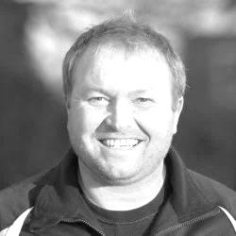
Good afternoon everyone. We welcome A.F.C. Hayes and all their supporters for today's game.

I am still gutted to be out off both F.A. Cup and F.A. Vase competitions to be honest, but the lads have come back fighting which is great to see. This is a great bunch of lads and it's very hard for me to pick the team every week.

This is good for me and my staff, as competition for places is very tough this year and long may it continue. I don't want to lose any more players after Agi Panayiotou departed for Chipstead.

We have had some good hard working performances so far but I still think there is a lot that me and the players can improve on, so hopefully there are more good things still to come at the club.

Cheers for all your support and have a safe trip home.

Manders

Club Captain - Sam Currie
Good afternoon and welcome to High Road for this afternoon’s fixture against AFC Hayes. We welcome all their players, coaching staff and fans.

The league has been fruitful for us so far this year as opposed to the cup games - seeing us unbeaten to date. We will be looking to extend this today with a solid performance against what we expect to be a well organised hard working side.

Last time out saw us pick another three points on the road at Spelthorne which has meant we are well set after the first few fixtures of the season. However we know it's a long hard season and the Combined Counties League brings up a lot of tough fixtures, game after game, and to this extent we will not be taking anything for granted and will be looking for a strong solid performance today.

With no midweek match again this coming week we will want to go into this break off the back of a positive performance and result!

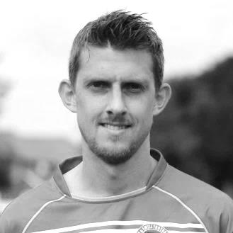
Thanks as always for your support.

Sam

Latest Results and Fixtures
Combined Counties League – Tuesday 8th September
Chessington & Hook United | 0-0 | Hanworth Villa
Epsom & Ewell | 3-1 | Colliers Wood United
Farnham Town | 1-2 | Badshot Lea
Knaphill | 2-2 | Windsor
Emirates F.A. Cup First Qualifying Round – Saturday 12th September
Chessington & Hook United | 2-3 | North Leigh
Hartley Wintney | 1-1 | Fleet Town
Hoddesdon Town | 3-1 | Ashford Town (Mx)
Tooting & Mitcham United | 2-1 | Farnham Town
Combined Counties League – Saturday 12th September
AFC Hayes | 0-2 | Colliers Wood United
Badshot Lea | 1-2 | Sutton Common Rovers
Cove | 0-5 | Knaphill
Guildford City | 5-2 | Redhill
Horley Town | 3-1 | Raynes Park Vale
Spelthorne Sports | 2-6 | Epsom & Ewell
Westfield | 1-1 | Camberley Town
Windsor | 0-0 | Chertsey Town
Combined Counties League Cup 1st Round – Monday 14th September
Sutton Common Rovers | 1-0 | Guildford City
Emirates F.A. Cup First Qualifying Round Replay – Tuesday 15th September
Fleet Town | 0-4 | Hartley Wintney
Combined Counties League Cup 1st Round – Tuesday 15th September
Bedfont Sports | 1-3 | Abbey Rangers
Horley Town | 4-1 | Staines Lammas
Windsor | 4-5 | Colliers Wood United
Combined Counties League – Tuesday 15th September
Ashford Town (Mx) | 2-1 | Farnham Town
Chertsey Town | 3-1 | AFC Hayes
Chessington & Hook United | 3-1 | Redhill
Combined Counties League – Saturday 19th September
Ashford Town (Mx) | V | Hanworth Villa
Camberley Town | V | Bedfont Sports
Chertsey Town | V | Spelthorne Sports
Cove | V | Guildford City
Epsom & Ewell | V | AFC Hayes
Farnham Town | V | Horley Town
Hartley Wintney | V | Chessington & Hook United
Knaphill | V | Colliers Wood United
Raynes Park Vale | V | Badshot Lea
Redhill | V | Windsor
Sutton Common Rovers | V | Westfield
Latest Results and Fixtures
Combined Counties League Cup 1st Round – Tuesday 22nd September
Farnham Town | V | Ash United
Combined Counties League – Tuesday 22nd September
AFC Hayes | V | Camberley Town
Badshot Lea | V | Chessington & Hook United
Horley Town | V | Sutton Common Rovers
Spelthorne Sports | V | Bedfont Sports
Windsor | V | Cove
Combined Counties League – Wednesday 23rd September
Guildford City | V | Knaphill
Combined Counties League – Friday 25th September
Hanworth Villa | V | Knaphill
Combined Counties League – Saturday 26th September
AFC Hayes | V | Horley Town
Badshot Lea | V | Chertsey Town
Bedfont Sports | V | Hartley Wintney
Chessington & Hook United | V | Cove
Epsom & Ewell | V | Farnham Town
Guildford City | V | Colliers Wood United
Redhill | V | Raynes Park Vale
Spelthorne Sports | V | Sutton Common Rovers
Westfield | V | Ashford Town (Mx)
Windsor | V | Camberley Town

Player Profile – Number 4 – Daryl Cooper-Smith
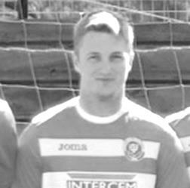
Daryl Cooper-Smith is the latest player to complete his profile for us.

He joined us in January of this year, making his debut in a 5-0 loss at Windsor, but scored his first goal a couple of weeks later with a great strike against Farnham Town and has scored regularly since.

Age: 25

Position: I don’t know yet, keeper?

Club supported: Liverpool

Favourite Food: Nandos

Favourite Film: The Jungle Book

Messi or Ronaldo? Dan Dean!

Favourite Drink: Vodka Lemonade

Favourite Ground played at: Loftus Road, Queens Park Rangers

Best moment for Epsom & Ewell: When Al McGregor returned to the club for the 29th time!

Describe the Gaffa in three words: Ginger – Ninja – “censored!”

Daryl’s Playing Stats: Debut 03/01/2015 - Appearances: 21 - Goals: 10
Win Ratio at May 2015 (% of games played in that we have won): 41.67%

From behind the goal
Horsham 3-0 Epsom & Ewell
F.A. Vase - First Qualifying Round - Sunday 6th September 2015

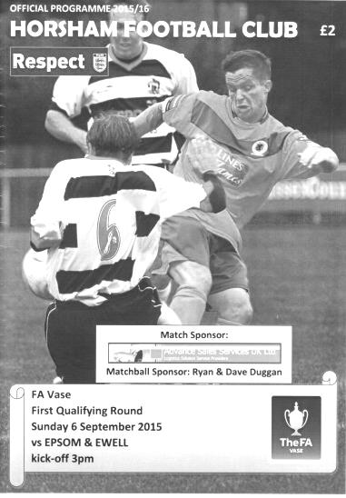
Salts stung by hornets as Vase dream dies in second half

There were some historical similarities about our defeat to Horsham. Twenty years ago this week we made our only previous competitive visit to Gorings Mead for an F.A. Vase tie that was also lost, while our last match with our opponents, eleven years previously, also finished three - nil in their favour.

More importantly this was our last chance to earn some F.A. prize money, following our departure from the F.A. Cup to Erith & Belvedere three weeks previously and yet again for a big match we had to make a significant positional switch before the match with Matt Tanton's absence forcing Glyn Mandeville to switch Sam Currie to left back with Rhys North coming in at right back. But to blame defeat on this alone would not be fair to Horsham who started on the front foot and got better in the second half with terminal consequences for our boys.

A far post header landed on the roof of our net in the opening moments but our first real problem occurred just nine minutes in when North clattered into a Horsham winger. The yellow card he would pick up as a result would come back to haunt us later.

We had a great opportunity in the 15th minute when Currie set up Rob Hendry on the left and his ball inside to Kyle Hough was taken in stride but from an angle he went for the far post, missing it by about eighteen inches. We wouldn't get a better chance in the remainder of the match as the hosts controlled the ball for much larger periods of time and we were not nearly so successful when we had possession.

Daryl Cooper-Smith, back as an outfield player at the expense of the unlucky Beckett Oliver after his Bank Holiday cameo in goal, hit a shot well from twenty-five yards but it was straight at the keeper who made the save, while the same story was occurring at the other end with the Hornets striking at goal frequently but not really troubling Michael Eacott. As the half concluded Hendry had a shot deflected off the arm of a defender for a corner and whilst it would have been a harsh call for a penalty, we've all seen them given before.

You always need things like that to go your way in a tight encounter but we appear to be always out of luck in Vase matches and this was the case again, as we conceded to

an unlucky own goal from Sam Currie after 48 minutes. A good run from the Horsham left winger gave North trouble as he was unable to dive in after his earlier yellow and when the ball came into the near post, our Captain got there ahead of everyone but with the worst possible result and the hosts were ahead.

Hendry tried to reduce the deficit after Hough put him through on the right and he cut back before curling the ball just over the bar. There were others in supporting roles who were frustrated as they would have liked the ball, but as a striker I felt that he was right to have a try. The real problem was that we were seeing very little of the ball. Slowly we began to find ourselves being pushed further back and they nearly scored a fine second goal as a ball from the right was chest controlled and then volleyed at Eacott in one movement, although fortunately for big Mike it was straight at him.

Eacott tipped a free kick over the bar before we brought Craig Hastings on for North with James Taylor moving to right back. However, our substitute's first touch was awful and he was robbed, the chance coming through to Terry Dodd, but with only our keeper to beat, he curled his shot around him and off the foot of our post.

Eacott made another low save and then tipped over a fine strike that was arrowing towards the top corner after 74 minutes as we struggled to gain any sort of control in the match. Matt Ferdinando won a free kick with a dangerous run that was ended crudely on the edge of the area but substitute Alex McGregor's free kick was not one of his best and sailed over the bar. Our right winger won another free kick shortly after this, being unlucky to pick up a yellow card for just trying to get past his man. To be fair to the referee he then searched for and found the hiding Horsham defender to give him a card too.

Our final opportunity came from that free kick in the 84th minute. The delivery had their keeper stretching and as he came down with the ball he dropped it, right behind Hough who turned, saw the ball and poked it in the net. However, he was adjudged to have fouled the keeper in the process and although any contact appeared extremely minimal, our striker didn't argue the decision. It made no difference in the end as a minute later the hosts had extended their lead. We had pushed forward but on the break a deep cross from the right wing was met at the far post by Kieran Pamment who drilled the ball low beyond Eacott in the 85th minute.

Hough nearly got through after this but was denied by a saving tackle for a corner and after Dale Marvell was cautioned for a foul a deep free kick was met by a shot by Pamment that was blocked back to him and he knocked the ball in from close range in the 94th minute.

It was unfortunate to concede the two late goals but overall we could have no complaints at the end and all we can do is curse our luck at having pulled out arguably the best teams in Kent and Sussex that we could have faced at this stage. Maybe next year!

Team: Michael Eacott, Rhys North, Sam Currie ©, James Taylor, Dale Marvell, Dan Dean, Daryl Cooper-Smith, Matt Farrell, Kyle Hough, Rob Hendry, Matt Ferdinando

Subs: Craig Hastings for North (68), Alex McGregor for Hendry (71)

From behind the goal
Epsom & Ewell 3-1 Colliers Wood United
Combined Counties League - Premier Division - Tuesday 8th September 2015

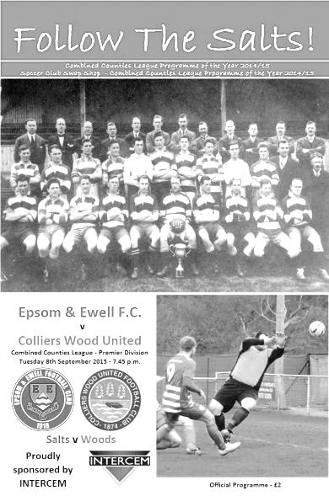
Salts double finally cuts down Wood

A very competitive but equally sporting encounter took place on Tuesday evening as we hosted Colliers Wood United; a team that are full of pace and power and very difficult to beat. However, we have an excellent home record against them and that continued as two late goals enabled us to secure a 3-1 win in front of 47 spectators that had chosen to put our game ahead of the England international match.

Following Sunday's loss only just over 48 hours previously we made a few changes to the line-up. At the back Sam Currie was the only starter from the Horsham match to retain his place and he was restored to his regular right back position at the expense of Rhys North, while Craig Hastings and Matt Tanton returned to the starting eleven and Dan Dean moved from midfield into the back four while James Taylor and Dale Marvell had a night off. In Dean's place in front of the defence was Alex McKay, making his first start of the season, while further forward Beckett Oliver and Alex McGregor returned at the expense of Rob Hendry and Daryl Cooper-Smith who were on the bench but would see action later.

Every time we face these opponents they seem to have a winger who was lightning fast and in the opening minutes Eli Ogunseye ran across the field and round all of our defenders, cutting in and shooting low, but Michael Eacott celebrating his twentieth birthday with a match against his old team, made a good save and the danger was cleared. In fact, more or less from that clearance we opened our account for the evening as Matt Ferdinando's excellent early delivery from the right hand side was played over the top in stride to Kyle Hough who held off the defender's challenge and slotted the ball past former Molesey keeper Wester Young and just inside the far post in just the tenth minute.

The game swung from end to end and the visitors had a couple of dangerous attempts on goal, but one was just over the bar while the other was deflected away for a corner, and in the 26th minute we should have extended our lead with Hough turning provider and setting McGregor through, but his finish lacked composure as he dragged the shot wide of the far post with just Young to beat.

Another dangerous ball in from Ferdinando was just ahead of the incoming Matt Farrell and only just missed the far post, and the final ten minutes of the half contained some more good chances for our boys as Oliver did well on the left and his deep cross was returned by Ferdinando but it was a bit pacy and McGregor did well to even fashion a volley from it, even

though it went just wide. Hough broke through moments later but in attempting to cut back he was muscled out of a shooting opportunity, although within two minutes he had another but was stretching a little and although his shot was powerful it lacked the direction and went low and wide.

Maybe surprised that they were still in the match after that barrage the Woods started the second half strongly and a couple of shots went just wide and just over our bar. It was clear that this game wouldn't finish at 1-0 and when Ogunseye fell in the area it was concerning but the referee, who had a much better view than I did, booked him for diving.

Rob Hendry came on in the 65th minute for Ferdinando who suffered an injury to his shoulder but we conceded shortly afterwards when Mario Embalo got in front of Craig Hastings and then went down. From where I was, it looked as though he was on his way down but whether that was because he had been clipped accidentally is hard to say. Certainly the referee, who had already produced a card for the earlier simulation felt there was a foul, although chose not to book Hastings so my guess is that he also felt it was accidental. Either way Ogunseye tucked away the penalty in the 67th minute.

Our response was to replace McGregor with Cooper-Smith in a slightly more advanced role and this turned the game back in our favour for the remainder of the match. His presence enabled us to use him as a target and gave Hough a bit more help. This almost bore fruit immediately when a header put Hough through on goal, but with the advancing keeper to beat he chose to lob him and the ball just didn't come down in time, clearing the bar by a couple of feet.

In the 74th minute Cooper-Smith produced a great cross from the right wing which Young palmed away and just for a moment it looked as though the ball would fall to one of our players but was cleared before we had a chance to get there. McKay sent Hendry away on the left but his pull back was just too far ahead of the incoming Hough. Moments later Oliver put in a dangerous low cross which had to be turned away for a corner. Hastings nearly met the set piece at the far post but a defender flicked the ball clear inches ahead of him.

As we turned up the pressure Hendry was just wide with a low shot, and although Oliver was replaced by Conor Davison shortly after this, he also contributed on the right and was involved in a good move that swung from right to left and then back for McKay but in trying too hard to keep the shot down he was wide with his effort.

We were well on top at this stage and in the 88th minute we retook the lead. Hendry on the left fed Hough. He dinked the ball in to Cooper-Smith who held his man off from six yards out, turned and smashed the loose ball into the net with his left foot. Celebrations were repeated four minutes later as a ball from the right was retrieved excellently by Farrell and his perfect first time left foot cross was headed in by Hough; the ball out of reach of the covering defenders on the line. That probably added an unfair gloss to the scoreline but it had been a very entertaining match and it was well worth coming out. Let's face it, we'll all see the Rooney goal often enough in the future anyway!

Team: Michael Eacott, Sam Currie ©, Matt Tanton, Dan Dean, Craig Hastings, Alex McKay, Beckett Oliver, Matt Farrell, Kyle Hough, Alex McGregor, Matt Ferdinando

Subs: Rob Hendry for Ferdinando (65), Daryl Cooper-Smith for McGregor (70), Conor Davison for Oliver (80)

The Spelthorne Sports match report will appear in next week’s programme

Club Records - 19th September
Date | Day | Competition |  | Opponents |  | Scorers
19/09/25 | Sat | F.A. Cup Preliminary Round | A | West Norwood | 0-1
19/09/31 | Sat | F.A. Cup Preliminary Round | A | West Norwood | 0-1
19/09/34 | Wed | London League Cup 1 | H | P.O.Engineers | 2-2 | T.Dunne, M.Wiggins
19/09/36 | Sat | F.A. Cup Preliminary Round | A | Woking | 1-3 | T.Dunne
19/09/53 | Sat | Amateur Cup  Preliminary Round | H | Civil Service | 5-0 | B.Wiles (3), D.Ford (2)
19/09/59 | Sat | Corinthian League | A | Horsham | 1-2 | J.Bangs
19/09/64 | Sat | F.A. Cup 2q | A | Wokingham Town | 4-2 | B.Mackay (3), D.Bruce
19/09/70 | Sat | F.A. Cup 1q | A | Guildford City | 0-5
19/09/78 | Tue | Isthmian League 1 | A | Wokingham Town | 2-0 | R.Parkin, T.Tuite
19/09/81 | Sat | F.A. Cup 1q | H | Herne Bay | 2-1 | M.Spratt, D.Hanks
19/09/89 | Tue | Isthmian League 2s | A | Bracknell Town | 3-0 | B.Perkins, G.Smith,  A.Van Sliedregt
19/09/92 | Sat | Isthmian League 3 | A | Northwood | 0-1
19/09/98 | Sat | F.A. Cup 1q | H | Shoreham | 2-1 | A.Rawlinson, J.Tome
19/09/09 | Sat | Combined Counties League  Premier Division | H | Chertsey Town | 3-2 | B.Hayward (2), R.Burns
19/09/12 | Wed | Combined Counties League  Premier Division | A | Croydon | 2-1 | D.Marvell (pen), A.McGregor
Historical Decades
90 years ago – Epsom Town F.C.
19/09/25 | Sat | F.A. Cup Preliminary Round | A | West Norwood | 0-1
80 years ago – Epsom F.C.
21/09/35 | Sat | F.A. Cup Preliminary Round | H | Met Police | 1-1 | G.Milnes (pen)
70 years ago – Epsom F.C.
22/09/45 | Sat | Friendly | H | Barking | 4-3 | S.Tingey, C.Holliday (2), J.Bates
60 years ago – Epsom F.C.
17/09/55 | Sat | Corinthian League | A | Uxbridge | 1-3 | G.Cairns
50 years ago – Epsom & Ewell F.C.
18/09/65 | Sat | Surrey Senior Cup 1q | A | Carshalton F.C. | 2-1 | T.Thomas, M.Griffiths
40 years ago – Epsom & Ewell F.C.
17/09/75 | Wed | F.A. Cup 1q replay | H | Southall & Ealing Borough | 3-3 | T.Wales, T.Tuite (pen), T.Lee
30 years ago – Epsom & Ewell F.C.
17/09/85 | Tue | Isthmian League  Premier Division | A | Tooting & Mitcham United | 2-2 | M.Gillings, P.Kemp
20 years ago – Epsom & Ewell F.C.
16/09/95 | Sat | Isthmian League 3 | A | Wingate & Finchley | 4-1 | S.Smith, A.Boxall, R.Dymond , G.Meakin
10 years ago – Epsom & Ewell F.C.
17/09/05 | Sat | F.A. Vase 1q | H | Petersfield Town | 3-1 | J.Goodwin, M.Tacey, C.Pritchard

History Corner – 19th September
90 years ago today we played our very first F.A. Cup match!!

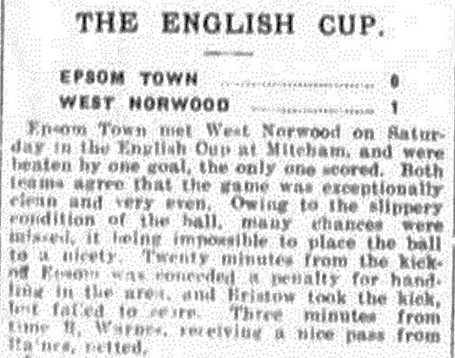
Exactly 90 years ago we played the first of our 169 F.A. Cup matches when hosting the famous West Norwood club at West Street.

They were a very well-known club, having even played our forerunners Ewell FC back around the turn of the century, and visiting the West Street enclosure as far back as 16th January 1897 for a Surrey Senior Cup tie. Since then they had become an Isthmian League club; a rare honour, although they had recently been relegated to the Athenian League due to their loss of a ground, something that would haunt them all the way to the late thirties when they would finally fold. A cautionary tale perhaps.

Anyway, we had our chances to win the tie with usually reliable Captain Sid Bristow missing a penalty but a late goal for the visitors enabled them to progress at our expense. Interestingly, one year before this the same opponents had been our first ever Amateur Cup opponent too, although we won that match 3-0 at Gorringe Park, one of many temporary homes the club would use since departing their main ground at the Herne Hill cycle track. Ironically that venue still exists!!

70 years ago this week Epsom F.C. won their first match after their enforced break for World War Two with a 4-3 win over Barking. Syd Tingey and J.Bates scored once each but Charlie Holliday got the other two and he has an interesting story.

Charlie, along with his brother Ken, who played far more for us, were descended from C.E Holliday, who played for us in the early twenties and once wrote in to the local papers to bemoan the quality of the officiating. Clearly that message must have got across to his two sons and Charlie went on to become a very successful Linesman; officiating in the Football League and in 1960, appearing at the recently built Nou Camp as Barcelona met Sofia in a European Cup tie!

62 years ago today Bill Wiles scored his first goals for the club with a hat trick against Civil Service; another former Isthmian League club before World War One. He scored four more a fortnight later and would go on to score 34 in 39 matches for us that season to fill at least some of the void that was created when Bill Goddard departed for Sutton in August 1953.

51 years ago today Bill Mackay scored a hat trick as we defeated Wokingham Town 4-2 in the F.A. Cup at their now lost ground at Finchampstead Road. Mackay, like the aforementioned Goddard, was not local, coming from and working in North West London, and it always amazes me how we were able to pick up players from so far away when there were many, larger clubs nearer to them.

40 years ago this week Trevor Lee scored his last goal for the club in an F.A. Cup replay with Isthmian League Premier Division Southall and Ealing Borough. They were three levels above us, yet we took them to a second replay before bowing out to a side containing a young Alan Devonshire.

6 years ago today we saw a great comeback. Trailing 2-0 to Chertsey Town, two goals from Ben Hayward, both in off the far post, brought us level and Robbie Burns scored the 90th minute winner. What a game!

Centre page for results

Centre page for results




Every Opponent A-Z
Over the years we have played many, many different opponents. Exactly how many is a difficult question, as it all depends on your definition. Are Camberley & Yorktown different to Camberley Town, or are Epsom Town different to Epsom F.C. or Epsom & Ewell F.C.?

In my analysis I have classed them as the same team, and will work through them all from A to Z. Some we have played many times, whilst others we have met just once or twice. Enjoy!


Park Royal: Played 11 - W4 D1 L6 - F32 A36 - PPG - 1.18 - Below Average

Coronation Road, Park Royal in Middlesex is a place that few of you are likely to have heard of. It was home to the grandly named Park Royal Stadium; home to Queens Park Rangers from 1907-1915 but was used a few years later with further success. It was built by the Great Western Railway for some reason and was situated, not unexpectedly, right next to the station halt there.

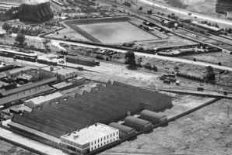
The Park Royal Stadium in 1933 with the Guinness Brewery in the foreground. The big road in the distance is the A40 with the road just in front of the ground being Coronation Road. The Brewery was demolished in the last decade while the ground is now covered by Johnsons Way.

In the 1928/29 season a tiny club by the name of Holland Athletic were playing our Reserves in the London League Division One and won the title at the first attempt. The following season they changed their name to Park Royal and repeated the Holland title success. For some reason they weren’t promoted on either of those occasions, but following 1930/31 where they won 25 of their 26 League games to win the title for the third time, they were finally moved up to the top flight.

The promotion heralded a run of further unbroken success as they went on to win the London League FOUR times in a row, with Epsom runners up on three occasions and third once.

Our first team met them for the first time on the Saturday, 2nd April 1932 where they defeated us 2-1 over there and eighteen days later repeated the scoreline at West Street, finishing their first season at the higher level as unbeaten Champions.

The following season we had an even better side and finished the season very strongly, winning our last ten league and cup fixtures. Even then we were unable to prevent them from winning the league by four points, although we became the first team to defeat them when winning 5-3 at West Street on 10th December 1932. We then handed them their first home League defeat in years when winning 2-1 at Coronation Road while on our late winning run (see programme). They only suffered one other defeat that season.

The following season was a good one for us, reaching the First Round of the F.A. Cup, yet so good were Park Royal that they finished FIFTEEN points clear of us in a league where there were only two points for a win and we played only 26 matches. They battered us 5-1 at West Street and 7-2 in West London.

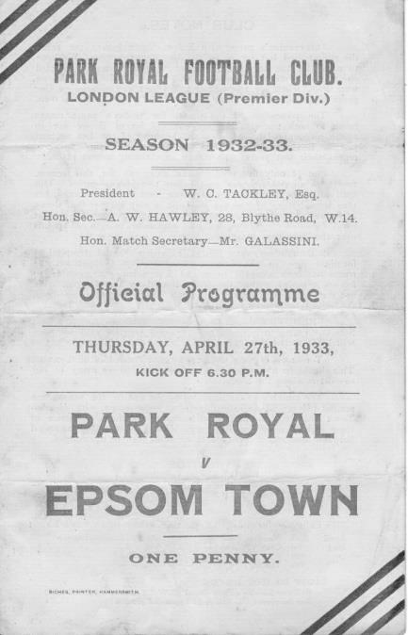
We defeated them 4-3 at home in 1934/35 requiring a hat trick from former Park Royal player E.H. Hannam to do it, but lost the return 5-2 as they won the title once more; seven points clear of us.

But there was a problem. After all this success you would have thought the Athenian League would have welcomed them with open arms, but clearly the issue must have been the ground. Grand though it appeared, it was aging and whether it was directly because of a failed application or not, more or less the whole team upped sticks and joined Southall in 1935, leaving their Reserves to continue the name, where as you might expect, they then finished bottom of the table and left the league, never to appear again.

Southall meanwhile reached the Third Round of the F.A. Cup, losing 4-1 to Watford at their shiny, new and impressive Western Road ground and set the process rolling for them to become an established club for many years; also reaching the Semi-Final of the Amateur Cup in 1953.

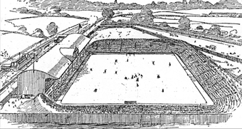
There is no doubt in my mind that without this incredibly successful team directly in our way, we would have had far more titles back then with an inevitable promotion to the Athenian League but it never came. Of course, for Park Royal it never came either.

Left: An artist’s impression of the ground when QPR were there.

AFC Hayes – History

The club was formed in 1974, springing from local Saturday sides Charville and Hayes North.

Success soon followed in the lower divisions of the Hayes and District Sunday League culminating in winning the Middlesex Sunday Junior Cup. Success continued with two League and Cup winning doubles before a switch to Saturday football in 1982 joining the now defunct South West Middlesex League.

Brook House then became founder members of The Middlesex County League before they joined the London Spartan League in 1989 when they were awarded senior status. In their first season, despite not finishing in one of the two promotion spots they were promoted to the Premier Division.

In 1992 the club had their floodlights erected and to mark the occasion, Chelsea were the first opponents under lights at Farm Park. In the same season, the final of the Spartan League Cup was reached, but Cheshunt took the trophy.

With the advent of their lights, the club was able to enter the F.A. Cup, and on two occasions they have reached the first qualifying round, most notably in 1995/1996 when they held Conference side Stevenage Borough to a 0-0 draw away only to lose the replay at home.

In 1997 Brook House appointed Mickey Harvey as manager with the express purpose of linking the Youth and Senior set ups. The move proved very successful as in its first season the club were Spartan South Midlands Premier Division (South) champions.

In 1999/2000 the club were runners up in the Premier Division of The Spartan South Midlands League and were Premier Division Cup winners. At the end of the 2001/2002 season, Manager Mickey Harvey decided to try pastures new, with Bob Strutton taking over.

2003/004 saw all the hard work and belief in younger players pay off, and we were never out of the top three in the league, eventually achieving second place. The lads also won the Challenge Trophy and were runners - up in the Premier Cup. Having just missed out promotion to the new National Step 4, we were invited into the Ryman Isthmian League Division 2.

In the close season, Bob decided to call it a day, so the Club again promoted from within. Joe Mitchell as manager with Colin Murphy as assistant and head coach.

2004/05 was a very good year - 3rd in the league behind Ware and Witham Town and last 16 of the FA Vase. In 2005/6 we won the last ever Isthmian League Associate Members Trophy beating Hertford 3 - 1 in the final. That placing and the E Level ground -grading saw us promoted to the newly -formed Step 4 Level and into The Southern League South & West Division.

After a promising start to the season we had a very indifferent second half, but we managed to achieve our main ambition of staying at this level. The highlight was coming runners-up in the Middlesex Senior Charity Cup.

From 2007-2008 the club started with the new name for our senior sides AFC HAYES. The Youth section are still carrying on our historic club name.

The 2008-2009 Season was the most successful season to date and the team finished 7th in the Southern League. This was overshadowed by winning the Middlesex Senior Cup for the very first time in the club's history. A 2-0 win over Hendon brought the trophy back to Farm Park.

During the next few seasons AFC Hayes consolidated in the Southern League and challenged for the Division One Central play-offs in 2011/12.

In 2012-13 we appointed Ian Crane who rebuilt the team. He was joined by Graham Goode as Assistant but in early December 2014 Graham left us followed by Ian’s resignation after xmas 2014. We appointed Paul Palmer and his assistant Colin Brown quickly, hoping to turn it around but were unable to escape relegation.

Match and Ball Sponsorships – 2015/16
Opponent | Date | Match and Match Ball Sponsor
Hoddesdon Town | 18/07/15 | Geoff Dyke
Windsor | 08/08/15 | Club President Stella Lamont
Erith & Belvedere | 16/08/15 | Mike Lovett
Raynes Park Vale | 31/08/15 | EEFC Management Committee
Colliers Wood United | 08/09/15 | Bookham Building Shop – www.buildingshop.co.uk
AFC Hayes | 19/09/15 | John Bonner
Farnham Town | 26/09/15
Chertsey Town | 17/10/15 | Club Media Officer – Richard Lambert
Dorking Wanderers (SSC) | 20/10/15
Chessington & Hook United | 07/11/15
Hanworth Villa | 21/11/15
Guildford City | 05/12/15
Cove | 08/12/15
Sutton Common Rovers | 19/12/15
Redhill | 02/01/16
Spelthorne Sports | 16/01/16
Hartley Wintney | 30/01/16
Bedfont Sports | 13/02/16
Horley Town | 27/02/16
Knaphill | 12/03/16
Westfield | 26/03/16
Badshot Lea | 09/04/16
Camberley Town | 16/04/16
Ashford Town (Mx) | 30/04/16
For League, League Cup and Surrey Senior Cup Matches:
Match sponsorship - £40.00 Match ball sponsorship - £25.00. Combined £55.00.
For F.A. Cup and F.A. Vase matches:
Match sponsorship - £50.00 Match ball sponsorship - £30.00. Combined £65.00.

Sponsorship includes: (x2 for match, x3 for match and ball)

Admission, programmes, hospitality and advertising and mascot for the day (if required).
If you are interested, just speak to a Committee Member, or drop me an email at: richard.c.lambert@gmail.com


We also thank our Kit Sponsors INTERCEM

Player Sponsorship
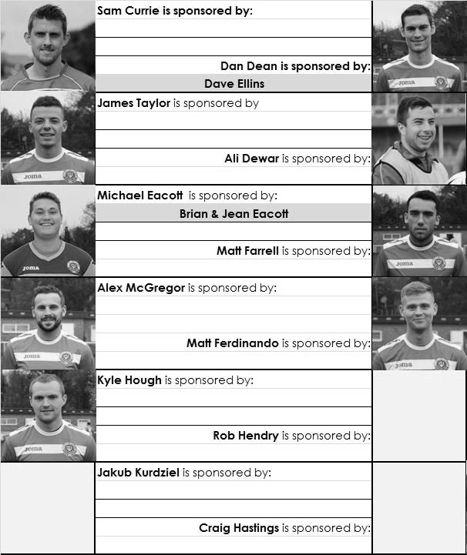

Here is the current list for the 2015/16 season showing all of our players and Management that are currently available for sponsorship this season. Pictures for our new players will feature in next week’s programme.

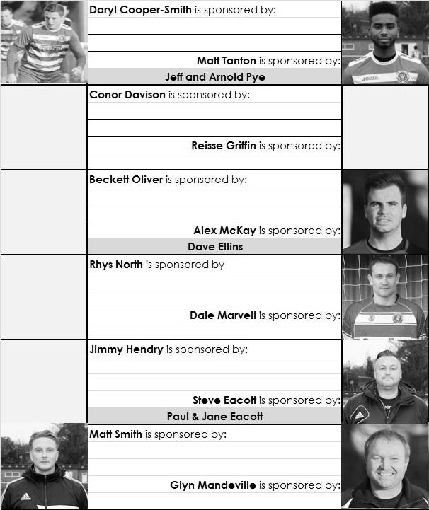
Sponsorship costs just £40 and it is easy to do. Just select a player who has not been previously sponsored and let a Committee Member know that you would like to sponsor them. Beware though. Until we have received the money it is possible for someone to jump in front of you, so don’t delay, sponsor today!

First Eleven Appearances - (max 9 – including Spelthorne Sports – 12/09/15)
Name | Debut | 2014/15 |  |  |  | Career Totals
Name | Debut | App | Sub | Total | Goals | App | Sub | Total | Goals
AJAYI Tayo | 22/08/2015 | 0 | 1 | 1 | 0 | 0 | 1 | 1 | 0
COOPER-SMITH Daryl | 03/01/2015 | 6 | 3 | 9 | 4 | 15 | 6 | 21 | 10
CURRIE Sam | 04/08/2012 | 9 | 0 | 9 | 0 | 117 | 9 | 126 | 2
DAVISON Conor | 22/08/2015 | 0 | 2 | 2 | 0 | 0 | 2 | 2 | 0
DEAN Dan | 02/08/2014 | 9 | 0 | 9 | 0 | 45 | 1 | 46 | 0
DEWAR Ali | 29/10/2011 | 0 | 0 | 0 | 0 | 55 | 35 | 90 | 10
EACOTT Michael | 02/08/2014 | 8 | 0 | 8 | 0 | 54 | 0 | 54 | 0
FARRELL Matt | 02/08/2014 | 8 | 0 | 8 | 1 | 49 | 3 | 52 | 8
FERDINANDO Matt | 20/09/2014 | 5 | 0 | 5 | 0 | 32 | 4 | 36 | 6
GRIFFIN Reisse | 08/08/2015 | 5 | 0 | 5 | 0 | 5 | 0 | 5 | 0
HASTINGS Craig | 08/08/2015 | 4 | 3 | 7 | 0 | 4 | 3 | 7 | 0
HENDRY Rob | 08/08/2015 | 8 | 1 | 9 | 3 | 8 | 1 | 9 | 3
HOUGH Kyle | 14/08/2007 | 9 | 0 | 9 | 7 | 305 | 15 | 320 | 178
KURDZIEL Jakub | 29/08/2015 | 1 | 0 | 1 | 0 | 1 | 0 | 1 | 0
MARVELL Dale | 15/01/2000 | 6 | 1 | 7 | 0 | 267 | 46 | 313 | 85
MCGREGOR Alex | 08/08/2009 | 2 | 2 | 4 | 1 | 174 | 58 | 232 | 28
MCKAY Alex | 20/12/2008 | 2 | 1 | 3 | 0 | 87 | 27 | 114 | 8
NORTH Rhys | 16/08/2015 | 1 | 3 | 4 | 0 | 1 | 3 | 4 | 0
OLIVER Beckett | 29/08/2015 | 2 | 1 | 3 | 0 | 2 | 1 | 3 | 0
PANAYIOTOU Savvas | 03/01/2015 | 2 | 0 | 2 | 0 | 18 | 3 | 21 | 3
SMITH Matt | 08/08/2009 | 0 | 0 | 0 | 0 | 91 | 43 | 134 | 10
TANTON Matt | 02/08/2014 | 7 | 0 | 7 | 0 | 25 | 4 | 29 | 1
TAYLOR James | 26/08/2013 | 5 | 1 | 6 | 0 | 61 | 9 | 70 | 3
Own Goal |  |  |  |  |  |  |  |  | 1

Salts Super Six Predictor
The Salts Super Six Predictor Competition is live again and the tickets are on sale at today’s game to the left of the gate. We are back with the Premier League and five of these matches are to be played this afternoon with one later on this evening.

The competition is easy to play! To win, you simply need to predict the results of six matches correctly from the three options, fill in the form and make sure it is back with our sellers before the deadline on the ticket.

If you are a club regular, you just need to place your name on the sheet, although if you aren’t, then we’ll need a contact number from you too. We will announce any winners on the website within three working days, so don’t worry we won’t miss you!

We nearly had a winner last week but the jackpot keeps rising and is already up to £177 How much higher can it go?

Please note that if there is more than one winner, the prize pot would be shared between the winners. All you need to do now is have a go, as many times as you like!

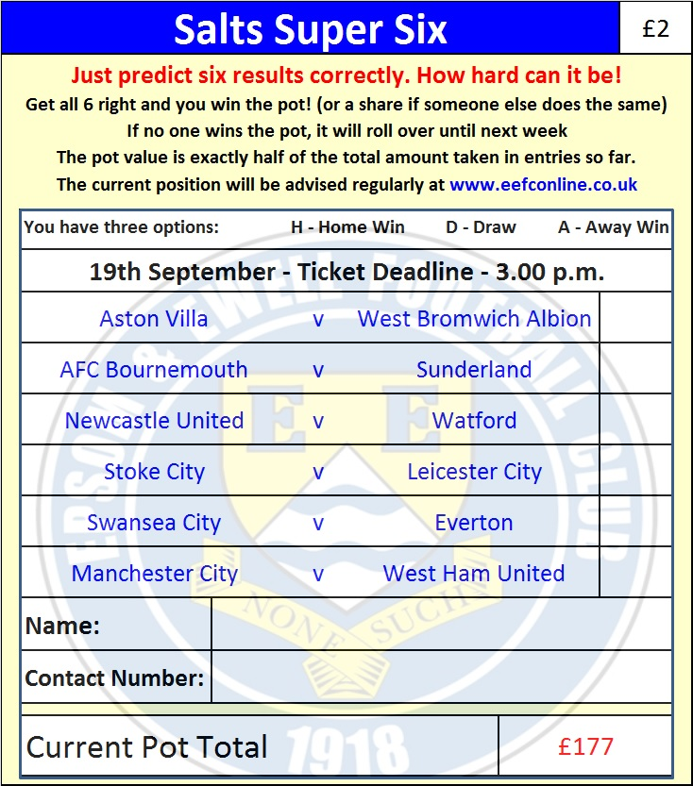

Good luck!

Combined Counties League – Premier Division
Saturday, 19th September 2015 - Kick-off 3.00 p.m.
Epsom and Ewell  (Royal Blue & White hoops) | V |  | AFC Hayes  (Yellow and Black stripes)
Squad | NUMBERS
Michael Eacott |  |  | Bobby Khiara
© Sam Currie |  |  | Billy Frazer
Matt Tanton |  |  | Christian Barrett
Dale Marvell |  |  | Jerome Eccleston
James Taylor |  |  | Daniel McDonnell
Dan Dean |  |  | Cameron Gilmartin
Matt Farrell |  |  | Mike Ferguson
Alex McKay |  |  | Dujon Desaguarante
Kyle Hough |  |  | Jake Knight
Daryl Cooper-Smith |  |  | Mark Nichols
Rob Hendry |  |  | Carlton Stewart
Reisse Griffin |  |  | Max Hubbard
Conor Davison |  |  | Jordan Berry
Jakub Kurdziel |  |  | Josh Quadry
Rhys North |  |  | Calum McCarroll
Tayo Ajayi |  |  | Ronnell Dennis
Matt Ferdinando |  |  | Luke Baldwin
Craig Hastings |  |  | Junior Scott
Beckett Oliver |  |  | Sam Saydee
Alex McGregor |  |  | Samuel Mazurek
David Neill |  |  | Cyrus Vanterpool
 |  |  | Silas Willoughby
Glyn Mandeville | MANAGER |  | Paul Palmer
Matt Smith | ASSISTANT |  | Matt Penfold
Steve Eacott / Alex McKay / Jimmy Hendry | COACHES / PHYSIO
REFEREE: M.Coen (Worcester Park)
ASSISTANTS: D.Olugunna (Wallington), T.Gilmore (Nutfield)
Today’s Match and Match Ball are sponsored by
regular supporter and occasional Assistant Referee, John Bonner!

OUR NEXT VISITORS TO HIGH ROAD
Farnham Town
Saturday 26th September 2015 - Kick-off 3.00 p.m.
Combined Counties League – Premier Division

